В английском языке обычно различают следующие части речи:
- глаголы (verbs)
- существительные (nouns)
- артикли (articles)
- прилагательные (adjectives)
- местоимения (pronouns)
- числительные (numerals)
- наречия (adverbs)
- предлоги (prepositions)
- союзы (conjunctions)

Part I
Unit I
Read and translate the following text. Write down unknown words.
British society
The English are a nation of stay-at-home. "There is no place like home," they say. And when the man is not working he is at home in the company of his wife and children and busies himself with the affairs of the home. "The Englishman's home is his castle," is a saying known all over the world. And it is true. A "typical" British family used to consist of mother, father and two children, but in recent years there have been many changes in family life. Some of these have been caused by new laws and others are the result of changes in society. For example, since the law made it easier to get a divorce, the number of divorces has increased. In fact one marriage in every three now ends in divorce. This means that there are a lot of one-parent families. Society is now more tolerant than it used to be of unmarried people, unmarried couples and single parents. Another change has been caused by the fact that people are living longer nowadays, and many old people live alone following the death of their partners. As a result of these changes in the pattern of people's lives, there are many households which consist of only one person or one person and children. You might think that marriage and the family are not so popular as they once were. However, the majority of divorced people marry again, and they sometimes take responsibility for a second family. Members of a family - grandparents, aunts, uncles, cousins - keep in touch, but they see less of each other than they used to. This is because people often move away from their home town to work, and so the family becomes scattered. Christmas is the traditional season for reunions. Although the family group is smaller nowadays than it used to be, relatives often travel many miles in order to spend the holiday together. In general, each generation is keen to become independent of parents in establishing its own family unit, and this fact can lead to social as well as geographical differences within the larger family group. Relationships within the family are different now. Parents treat their children more as equals than they used to, and children have more freedom to make their own decisions. The father is more involved with bringing up children, often because the mother goes out to work. Increased leisure facilities and more money mean that there are greater opportunities outside the home. Although the family holiday is still an important part of family life (usually taken in August, and often abroad) many children have holidays away from their parents, often with a school party or other organized group. Who looks after the older generation? There are about 10 million old-age pensioners in Britain, of whom about 750,000 cannot live entirely independently. The government gives financial help in the form of a pension but in the future it will be more and more difficult for the nation economy to support the increasing number of elderly. At the present time, more than half of all old people are looked after at home. Many others live in Old Peoples' Homes, which may be private or state owned.
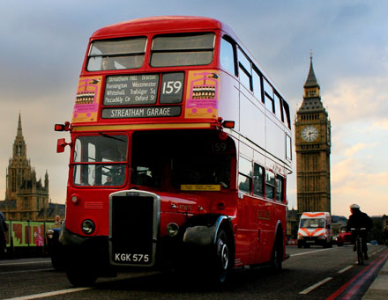

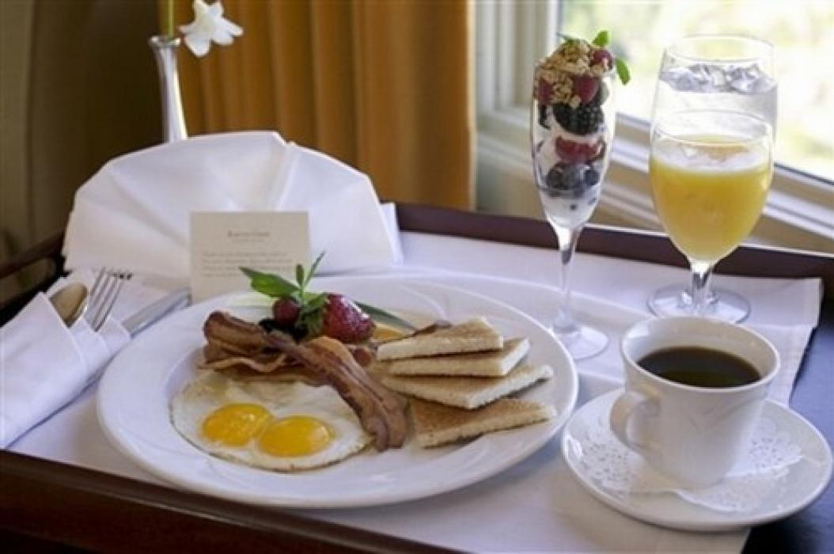

Unit II
Read and translate the following text. Write down unknown words.
The economic development of the UK
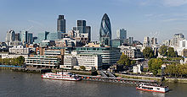 | The UK has a partially regulated market economy. Based on market exchange rates the UK is today the sixth-largest economy in the world and the third-largest in Europe after Germany and France, having fallen behind France for the first time in over a
decade in 2008.The Bank of England is the UK's central bank and is responsible for issuing the nation's currency, the pound sterling. Pound sterling is the world's third-largest reserve currency (after the U.S. Dollar and the Euro).
The UK is the world’s ninth largest oil producer and the fifth largest gas producer. Developing North Sea oil and gas has created a huge support industry offering equipment and services to oil and gas company at home and abroad. British Petroleum (BP) is the eleventh largest industrial grouping in the world and the second largest in Europe.
The UK service sector makes up around 73% of GDP. London is one of the three "command centres" of the global economy (alongside New York City and Tokyo), is the world's largest financial centre alongside New York.
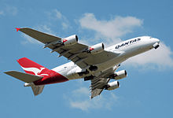 | The automotive industry is a significant part of the UK manufacturing sector and employs over 800,000 people, with a turnover of some £52 billion, generating £26.6 billion of exports. The aerospace industry of the UK is the second- or third-largest national aerospace industry
depending upon the method of measurement and has an annual turnover of around £20 billion. British aviation equipment companies have made significant technological advances. They supply navigation and landing systems, engine and flight controls, power systems, flight deck control and information systems. British firms have also been active in developing flight simulators, and “fly-by-wire” technology, in which the aircraft’s control surfaces are manipulated electronically.
The most rapid growth in recent years has been in pharmaceuticals, pesticides and cosmetics. ICI is the fourth largest chemical company in the world and one of the largest exporting companies. Britain is active in biotechnology research and has made major advances in the development of drugs such as human insulin and genetically-engineered vaccines.
Although Britain is a densely populated, industrialized country, agriculture is still one of its most important industries. Dairying is most common in the west of England, where the wetter climate encourages the growth of good grass.
The south-eastern coast is well-known for its picturesque scenery and mild climate and a number of popular resorts. On the southern coast of England there are many large ports, among them: Southampton, Portsmouth, Plymouth.

Unit III
Read and translate the following text. Write down unknown words.
LONDON
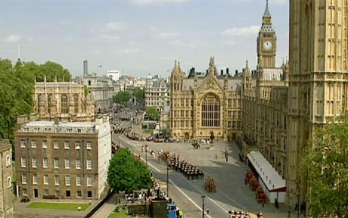
London is the capital city of England and the United Kingdom. It is known as the largest metropolitan area in the United Kingdom, and the largest urban zone in the European Union. London is governed by the elected Mayor of London and the London Assembly. Until 1889 the name "London" was officially applied only to the City of London but since then it has also referred to the County of London and now Greater London.
London is located on the River Thames. London was founded by the Romans about 2000 ago. It was called Londinium. There were some theories concerning the etymology of London.It is an ancient name and is found in some sources from the 2nd century. It is recorded as Londinium, which points to Romano-British origin. Some scientists originated the name from a supposed King Lud. From 1899 it was commonly accepted that the name was of Celtic origin and meant place belonging to a man called *Londinos. In 1998 an explanation was put forward that it is derived from the pre-Celtic Old European *(p)lowonida, meaning 'river too wide to ford', and suggested that this name was given to the part of the River Thames which flows through London.
London is known as a centre of arts, commerce, education, entertainment, fashion, finance, healthcare, media, professional services, research and development, tourism and transport. It is the world's largest financial centre alongside New York City and some other big and well known cities of the world. London Heathrow is the world's busiest airport by number of international passengers. London's 43 universities form the largest concentration of higher education in Europe. Since 2012 London will be considered the first city to host the modern Summer Olympic Games three times. (The Summer Olympics were hold twice in 1908 and 1948.)
London has a diverse range of peoples, cultures and religions and more than 300 languages are spoken within its boundaries. In July 2010 Greater London had an official population of 7,825,200, making it the most populous municipality in the European Union.
There is no such a city in the world except London which contains four World Heritage Sites: the Tower of London; Westminster Abbey, and St Margaret's Church; and the historic settlement of Greenwich (in which the Royal Observatory marks the Prime Meridian (0 longitude) and GMT). There are some other famous landmarks: Buckingham Palace, the London Eye, Piccadilly Circus, St Paul's Cathedral, Tower Bridge, Trafalgar Square and Wembley Stadium. London is home to numerous museums, galleries, libraries, sporting events and some other cultural institutions, including the British Museum, National Gallery, British Library, Wimbledon and 40 theatres. London's Chinatown is the largest in Europe. The London Underground is considered to be the oldest underground railway network in the world. And were there any famous writers in London? Of course there were. Since the 16th century the name of William Shakespeare is known to everyone
There are some large parks in London. The largest parks are the Royal Parks of Hyde Park, its neighbour Kensington Gardens and Regent's Park. Regent's Park contains London Zoo, the world's oldest scientific zoo, and is located near the tourist attraction of Madame Tussauds Wax Museum.
Closer to central London are the smaller Royal Parks of Green Park and St. James's Park. Hyde Park in particular is popular for sports and sometimes hosts open-air concerts. A number of large parks are located outside the city centre, including the remaining Royal Parks of Greenwich Park and Bushy Park and Richmond Park, as well as Victoria Park. Primrose Hill to the north of Regent's Park is a popular spot to view the city skyline.
Some more informal, semi-natural open spaces also exist, including Hampstead Heath of North London. This incorporates Kenwood House, the former stately home and a popular location in the summer months where classical musical concerts are held by the lake, attracting thousands of people every weekend to enjoy the music, scenery and fireworks.
London is home to designers Vivienne Westwood, Galliano, Stella McCartney, Manolo Blahnik, and Jimmy Choo among others; its art and fashion schools make it an international centre of fashion alongside Paris, Milan and New York.
There are a variety of regular annual events in the city. The beginning of the year is celebrated with the relatively new New Year's Day Parade, fireworks display at the London Eye, and the world's second largest street party, the Notting Hill Carnival is held during the late August Bank holiday each year. Traditional parades include November's Lord Mayor's Show, a centuries-old event celebrating the annual appointment of a new Lord Mayor of the City of London with a procession along the streets of the City, and June's Trooping the Colour, a formal military pageant performed by regiments of the Commonwealth and British armies to celebrate the Queen's Official Birthday.
London is home to many museums, galleries, and other institutions, many of which are free of admission charges and are major tourist attractions as well as playing a research role. The first of these is the British Museum in Bloomsbury, it was established in 1753. Originally containing some antiquities, natural history specimens and the national library, the museum now has 7 million artefacts from around the globe. In 1824 the National Gallery was founded to house the British national collection of Western paintings; this now occupies a prominent position in Trafalgar Square. In the latter half of the nineteenth century the locale of South Kensington was developed as "Albertopolis". Three major national museums are located there: the Victoria and Albert Museum, the Natural History Museum and the Science Museum.
London is one of the major classical and popular music capitals of the world and is home to major music corporations, such as EMI, as well as countless bands, musicians and industry professionals.

КОНТРОЛЬНАЯ РАБОТА №1
ВАРИАНТ I
Задание I. Прочитайте и переведите весь текст устно. Перепишите 8, 9, 10, 11 абзацы текста и переведите их письменно. К собеседованию подготовьте чтение и перевод всего текста.
Liverpool
1 Liverpool is a city of Merseyside, England, along the eastern side of the Mersey Estuary. It was founded as a borough in 1207 and was granted city status in 1880. Liverpool had a population of 435,500. Inhabitants of Liverpool are referred to as Liverpudlians but are also colloquially known as "Scousers", in reference to the local dish known as "scouse", a form of stew. Liverpool's status as a port city has contributed to its diverse population, which was drawn from a wide range of peoples, cultures, and religions, particularly those from Ireland. The city is also home to the oldest Black African community in the country and the oldest Chinese community in Europe. Historically Liverpool was a major port. By the early 19th century, 40% of the world's trade passed through Liverpool's docks. Liverpool and Manchester became the first cities to have an intercity rail link, through the Liverpool and Manchester Railway.
2 Liverpool is internationally known for music and is recognised by Guinness World Records as the World Capital City of Pop. The popularity of The Beatles, Gerry and the Pacemakers and the other groups contributes to Liverpool's status as a tourist destination; tourism forms a significant part of the city's modern economy. Several areas of the city centre were granted World Heritage Site status by UNESCO in 2004. Referred to as the Liverpool Maritime Mercantile City, the site comprises six separate locations in the city including the Pier Head, Albert Dock and William Brown Street and includes many of the city's most famous landmarks. Liverpool is also the home of two Premier League football clubs, Liverpool F.C. and Everton F.C.. Matches between the two clubs are known as the Merseyside derby.
3 The original street plan of Liverpool is said to have been designed by King John and was granted a royal charter, making it a borough. The original seven streets were laid out in a H shape:
- Bank Street (now Water Street)
- Castle Street
- Chapel Street
- Dale Street
- Juggler Street (now High Street)
- Moor Street (now Tithebarn Street)
- Whiteacre Street (now Old Hall Street)
4 The Housing Act 1919 resulted in mass council housing building across Liverpool during the 1920s and 1930s. Thousands of families were rehoused from the inner-city to new suburban housing estates. For periods during the 19th century the wealth of Liverpool exceeded that of London itself, and Liverpool's Custom House was the single largest contributor to the British Exchequer. Liverpool's status can be judged from the fact that it was the only British city ever to have its own Whitehall office.
5 Liverpool was also the site of the UK's first provincial airport, operating from 1930. Ferries, railways, transatlantic steamships, municipal trams, electric trains and the helicopter were all pioneered in Liverpool as modes of mass transit. In 1829 and 1836 the first underground railway tunnels in the world were constructed under Liverpool.
6 The first School for the Blind, Mechanics' Institute, High School for Girls, council house and Juvenile Court were all founded in Liverpool. The RSPCA, NSPCC, Age Concern, Relate, Citizen's Advice Bureau and Legal Aid all evolved from work in the city.
7 In the field of public health, the first lifeboat station, public baths and wash-houses, sanitary act, medical officer for health, district nurse, slum clearance, purpose-built ambulance, X-ray medical diagnosis, school of tropical medicine, motorised municipal fire-engine, free school milk and school meals, cancer research centre, and zoonosis research centre all originated in Liverpool. The first British Nobel Prize was awarded in 1902 to Ronald Ross, professor at the School of Tropical Medicine, the first school of its kind in the world. Orthopedic surgery was pioneered in Liverpool by Hugh Owen Thomas, and modern medical anesthetics’ by Thomas Cecil Gray.
8 In finance, Liverpool founded the UK's first Underwriters' Association and the first Institute of Accountants. The Western world's first financial derivatives (cotton futures) were traded on the Liverpool Cotton Exchange in the late 1700s.
9 In the arts, Liverpool was home to the first lending library, athenaeum society, arts centre and public art conservation centre. Liverpool is also home to the UK's oldest surviving classical orchestra, the Royal Liverpool Philharmonic Orchestra. Shipowner Sir Alfred Lewis Jones introduced the banana to Great Britain in 1884. In 1897, the Lumière brothers filmed Liverpool, including what is believed to be the world's first tracking shot, taken from the Liverpool Overhead Railway – the world's first elevated electrified railway.
10 There are three tiers of government; the Local Council, the National Government and the European Parliament. Liverpool is officially governed by a Unitary Authority. However several services such as the Police and Fire and Rescue Service, continue to be run at a county-wide level.
11 Liverpool's historic position as one of the most important trading ports in the world has meant that over time many grand buildings have been constructed in the city as headquarters for shipping firms, insurance companies, banks and other large firms. The great wealth of this brought contributed to the development of grand civic buildings, which were designed to allow the local administrators to 'run the city with pride'.
Задание II. Выпишите все незнакомые слова. Найдите в тексте следующие слова и словосочетания, найдите их транскрипцию в словаре, выучите их. Знание слов будет проверяться на собеседовании.
поселение
горожане
население
железнодорожное сообщение
делать вклад
достопримечательности
благосостояние
фьючерсы
таможня
Нобелевская премия
биржа
Задание III. Найдите в 1,2 абзаце текста предложения, в которых употребляется глагол во времени Present Simple Active, выпишите и переведите их на русский язык.
Задание IV. Найдите в 1,11 абзаце текста предложения, в которых употребляется глагол во времени Present Perfect Active, выпишите и переведите их на русский язык.
Задание V. Найдите в 10 абзаце текста предложение, в которых употребляется конструкция There + be, выпишите и переведите его на русский язык.
Задание VI. Найдите в 4,6,8 абзаце текста предложения, в которых употребляется глагол в пассивном залоге, выпишите и переведите их на русский язык.
Задание VII. Найдите в 3,5 абзаце текста предложения, в которых употребляется количественные и порядковые числительные, выпишите и переведите их на русский язык.
Задание VIII. Найдите в 1,4,11 абзаце текста предложения, в которых употребляется прилагательные в разных степенях сравнения, выпишите и переведите их на русский язык.
Задание IX. Переведите предложения на русский язык, обращая внимание на значение предлогов.
1. When the man is not working he is at home in the company of his wife and children and busies himself with the affairs of the home.
2. As a result of these changes in the pattern of people's lives, there are many households which consist of only one person or one person and children.
3. Based on market exchange rates the UK is today the sixth-largest economy in the world.
4. The Bank of England is the UK's central bank and is responsible for issuing the nation's currency.
5. There are many large ports on the southern coast of England.
6. The hotel is near to the station.
7. The Notting Hill Carnival is held during the late August Bank holiday each year.
Задание IX. Задайте вопросы к выделенным словам.
1. Liverpool is officially governed by a Unitary Authority.
2. By the early 19th century, 40% of the world's trade passed through Liverpool's docks.

КОНТРОЛЬНАЯ РАБОТА №1
ВАРИАНТ II
Задание I. Прочитайте и переведите весь текст устно. Перепишите 8, 9, 10, 11 абзацы текста и переведите их письменно. К собеседованию подготовьте чтение и перевод всего текста.
Manchester
1 Manchester is a city and metropolitan borough in Greater Manchester, England. Population of Manchester was 498,800. Manchester is situated in the south-central part of North West England, fringed by the Cheshire Plain to the south and the Pennines to the north and east. The recorded history of Manchester began with the civilian settlement associated with the Roman fort of Mamucium, which was established in 79 AD on a sandstone bluff near the confluence of the rivers Medlock and Irwell.
2 The town of Manchester was granted a charter by Thomas Grelley in 1301 but lost its borough status in a court case of 1359. Until the 19th century, local government was largely provided by manorial courts, the last of which ended in 1846. In 1853 Manchester was granted city status in the United Kingdom. Historically, most of the city was a part of Lancashire, although areas south of the River Mersey were in Cheshire. Manchester is mentioned as having a market in 1282. Around the 14th century, Manchester received an influx of Flemish weavers, sometimes credited as the foundation of the region's textile industry. Manchester became an important centre for the manufacture and trade of woolens and linen. Significant quantities of cotton began to be used after about 1600, firstly in linen/cotton fustians, but by around 1750 pure cotton fabrics were being produced and cotton had overtaken wool in importance.
3 The Irwell and Mersey were made navigable by 1736, opening a route from Manchester to the sea docks on the Mersey. The Bridgewater Canal, Britain's first wholly artificial waterway, was opened in 1761, bringing coal from mines at Worsley to central Manchester. The canal was extended to the Mersey at Runcorn by 1776. The combination of competition and improved efficiency halved the cost of coal and halved the transport cost of raw cotton. Manchester became the dominant marketplace for textiles produced in the surrounding towns. A commodities exchange, opened in 1729, and numerous large warehouses, aided commerce. In 1780, Richard Arkwright began construction of Manchester's first cotton mill.
4 Throughout the Middle Ages Manchester remained a manorial township, but it began to expand "at an astonishing rate" around the turn of the 19th century. Manchester's unplanned urbanisation was brought on by a boom in textile manufacture during the Industrial Revolution, and resulted in it becoming the world's first industrialised city. An early 19th-century factory building boom transformed Manchester from a township into a major mill town and borough that was granted city status in 1853. In 1894 the Manchester Ship Canal was built, creating the Port of Manchester.
5 Much of Manchester's history is concerned with textile manufacture during the Industrial Revolution. The great majority of cotton spinning took place in the towns of south Lancashire and north Cheshire, and Manchester was for a time the most productive centre of cotton processing, and later the world's largest marketplace for cotton goods. Manchester was dubbed "Cottonopolis" and "Warehouse City" during the Victorian era. In Australia, New Zealand and South Africa, the term "manchester" is still used for household linen: sheets, pillow cases, towels, etc.
6 Engineering firms initially made machines for the cotton trade, but diversified into general manufacture. Similarly, the chemical industry started by producing bleaches and dyes, but expanded into other areas. Commerce was supported by financial service industries such as banking and insurance. Trade, and feeding the growing population, required a large transport and distribution infrastructure: the canal system was extended, and Manchester became one end of the world's first intercity passenger railway—the Liverpool and Manchester Railway.
7 Manchester has a notable place in the history of Marxism and left-wing politics; being the subject of Friedrich Engels' work The Condition of the Working Class in England in 1844. The first Trades Union Congress was held in Manchester (at the Mechanics' Institute, David Street), from 2 to 6 June 1868. Manchester was an important cradle of the Labour Party and the Suffragette Movement.
8 Manchester has the largest UK office market outside London. Manchester is a focus for businesses which serve local, regional and international markets. It is the fifth-largest financial centre in the United Kingdom outside London. Legal, accounting, management consultancy and other professional and technical services exist in Manchester.
9 The city is notable for its culture, music scene, scientific and engineering achievements, media links and sporting connections. Manchester's sports clubs include Premier League football teams, Manchester City and Manchester United. Manchester was the site of the world's first railway station, where scientists first split the atom and developed the first stored-program computer. There are two universities, including the largest single-site university in the United Kingdom, and has one of the country's largest urban economies. Manchester is also the third-most visited city in the United Kingdom by foreign visitors, after London and Edinburgh, and the most visited in England outside London.
10 Manchester's buildings display a variety of architectural styles, ranging from Victorian to contemporary architecture. The widespread use of red brick characterises the city.
11 Manchester is represented by three tiers of government, Manchester City Council ("local"), UK Parliament ("national"), and European Parliament ("Europe").
Задание II. Выпишите все незнакомые слова. Найдите в тексте следующие слова и словосочетания, найдите их транскрипцию в словаре, выучите их. Знание слов будет проверяться на собеседовании.
поселение
поместный суд
ткач
товарная биржа
товарный склад
судоходный
промышленная революция
железнодорожное сообщение
конгресс профсоюзов
местные, региональные и международные рынки
Задание III. Найдите в 1,7,10 абзаце текста предложения, в которых употребляется глагол во времени Present Simple Active, выпишите и переведите их на русский язык.
Задание IV. Найдите в 3,4,6 абзаце текста предложения, в которых употребляется глагол во времени Past Simple Active, выпишите и переведите их на русский язык.
Задание V. Найдите в 9 абзаце текста предложение, в которых употребляется конструкция There + be, выпишите и переведите его на русский язык.
Задание VI. Найдите в 2,5,11 абзаце текста предложения, в которых употребляется глагол в пассивном залоге, выпишите и переведите их на русский язык.
Задание VII. Найдите в 3,5,8 абзаце текста предложения, в которых употребляется количественные и порядковые числительные, выпишите и переведите их на русский язык.
Задание VIII. Найдите в 2,5,8 абзаце текста предложения, в которых употребляется прилагательные в разных степенях сравнения, выпишите и переведите их на русский язык.
Задание IX. Переведите предложения на русский язык, обращая внимание на значение предлогов.
1. A "typical" British family used to consist of mother, father and two children, but in recent years there have been many changes in family life.
2. Although the family holiday is still an important part of family life many children have holidays away from their parents, often with a school party or other organized group.
3. There are about 10 million old-age pensioners in Britain, of whom about 750,000 cannot live entirely independently.
4. He moved away from his home town to work in New York ten years ago.
5. The most rapid growth in recent years has been in pharmaceuticals, pesticides and cosmetics.
6. Tomorrow afternoon we’re going to play tennis from 3 o’clock until 4.30.
7. The Mediterranean Sea is between Europe and Africa.
Задание IX. Задайте вопросы к выделенным словам.
1. Much of Manchester's history is concerned with textile manufacture.
2. The first Trades Union Congress was held in Manchester from in June 1868.

Part II
Unit I
Read and translate the following text. Write down unknown words.

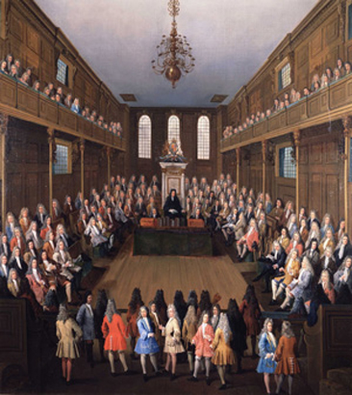  The House of Lords18th century | 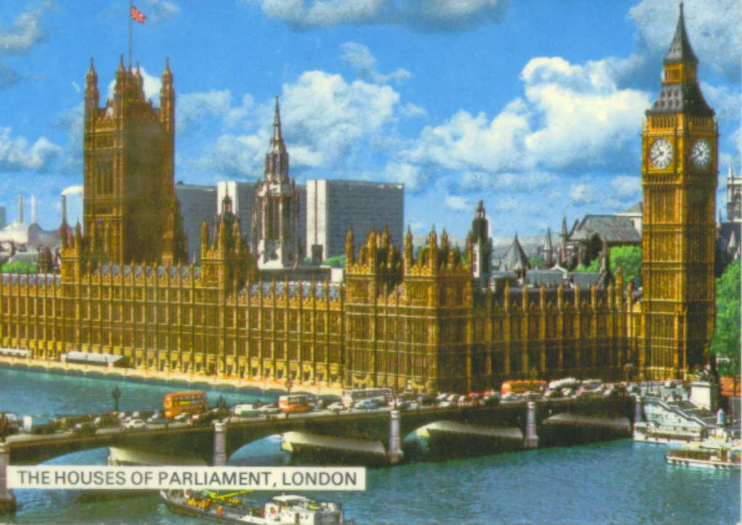  The Houses of Parliament
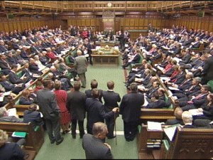  Modern British parliament | 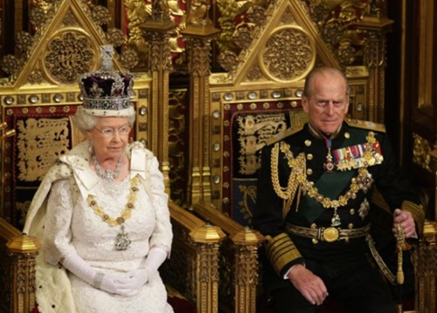  Queen Elizabeth Opens Parliament

UK Political system
The United Kingdom of Great Britain is a parliamentary democracy with a constitutional monarch, Queen Elizabeth II, as head of the State. The organs of government are: Parliament, the executive and the judiciary.
The legislature, Parliament, is the supreme authority. It comprises two chambers – the House of Lords and the House of Commons which sit separately and are constituted on different principles. The Commons is an elected body of members. The House of Lords is a hereditary Chamber. Substantial reform is being carried out in the upper house, the House of Lords, where it is proposed that the majority of members be appointed, with a minority elected, replacing the hereditary peers.
The executive consists of the central Government – that is the Prime Minister and the cabinet and other ministers, who are responsible for initiating and directing the national policy, government departments, local authorities and public corporations.
The Government derives its authority from the elected House of Commons.
A general election, for all seats in the House of Commons, must be held at least every five years. The Government is normally formed by the political party which is supported by the majority in the House of Commons. The party's leader is the Prime Minister appointed by the Queen. He chooses a team of ministers, of whom 20 or so are in the Cabinet. The second largest party becomes Her Majesty's Loyal Opposition with its own leader and 'Shadow Cabinet'. The House of Commons comprises members from the constituencies in England, Scotland, Wales and Northern Ireland who represent people whose history and traditions differ.
The judiciary determines common law and interprets status and is independent of both the legislature and the executive. There are four countries and three distinct jurisdictions in the United Kingdom: England and Wales, Scotland, and Northern Ireland. All share a legislature in the Westminster Parliament.
In Great Britain there is no written constitution, only customs, traditions and precedents. Constitutional law consists of statute law, common law, and constitutional conventions.

Unit II
Read and translate the following text. Write down unknown words.

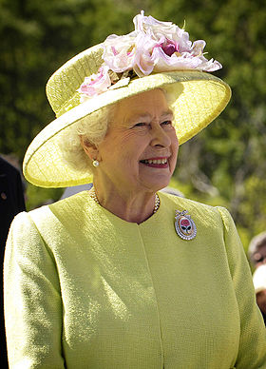
Елизавета II
12-я Королева Великобритании
"Elizabeth II, by the Grace of God of the United Kingdom of Great Britain and Northern Ireland and of Her other Realms and Territories Queen, Head of the Commonwealth, Defender of the Faith".
British Monarchy
The British monarchy clearly has great powers to survival; it is certainly the oldest institution of government in the United Kingdom. Queen Elizabeth II is descended from the Saxon monarchs who united England in the ninth century. When the Queen was born on the 21st of April 1926, her grandfather, King George V, was on the throne and her uncle was his heir. The death of her grandfather and the abdication of her uncle brought her father to the throne as King George VI.
Queen Elizabeth II is the symbol of the unity of the nation. She executes many ceremonial functions. She is the ultimate guardian of the constitution and must intervene where the normal machinery of government has broken down. In a few special cases the monarch can and indeed must exercise personal power. The occasions on which the power of the monarchy might be exercised are as follows:
1. The appointment of a Prime minister. The Queen must appoint the person who can form a government with the support of the House of Commons. This usually means the leader of the majority party as determined by a general election. Nowadays each party elects its leader. In the unlikely event of the electoral process not producing a clear winner the Queen might have to exercise a personal choice. For example, if a general election fails to produce an overall majority the existing Prime minister must probably be permitted to attempt to form a government. Failing that, the Queen should summon the leader of the next largest party.
2. The dismissal of a government and the dissolution of Parliament. If a government is defeated on a vote of confidence in the House of Commons but refuses to resign or to advise a dissolution the Queen could probably dismiss the government. The Queen could dismiss a government that violates a basic constitutional principle, for example by proposing legislation to abolish elections. In order to dissolve Parliament the Queen would require a meeting of the Privy Council.
3. Refusing a dissolution. The Prime minister may advise the monarch to dissolve Parliament but the Queen might refuse a dissolution if the Prime minister is acting clearly unconstitutionally.
4. The Queen might refuse a Prime ministerial request to appoint peers to the House of Lords where the reason for the request is to flood the Lords with government supporters. The precedents (1832 and 1910—1911) suggest that the monarch would have to agree to such a request but only after a general election.
5. The Royal Assent. The monarch has not refused royal assent to legislation since 1709. It appears to be a strong convention that royal assent must always be given. However the Queen might refuse royal assent where the refusal is on the advice of the Prime minister.
She can advise, encourage and warn. The monarch has access to all government documents and regularly meets the Prime minister. The monarch can express views in private to the government but there is no convention as to the weight to be given to them. But in reality she has little direct power that’s why it is often said “The Queen reigns but doesn’t rule”

Unit III
АННОТАЦИЯ ТЕКСТА
Аннотация (англ. annotation)- это предельно краткое изложение главного содержания документа, составленное в результате сжатия текста оригинала и в нескольких строчках дающее представление о его тематике.Аннотации бывают описательные, справочные, реферативные, рекомендательные и критические.
Аннотацию предваряет справка, в которой указываются: название работы на английском языке и перевод его на русский, автор, выходные данные (год, место издания). Кроме того, дня журналов - его название на английском языке, номер и год издания. Справка не обязательна (кроме названия статьи) при аннотировании учебных текстов.
Аннотация должна содержать основные проблемы, которые рассматриваются в данной статье. В заключительной части аннотации может быть общий вывод автора статьи или указание на один какой-то вопрос, которому в статье уделено особое внимание, а также рекомендация, для кого данная работа может представлять особый интерес.
Описательная аннотация включает от трех до десяти предложений (от 60 до 100 слов).
I. Клише, используемые вместо справки к аннотации:
Статья под названием...
Эта статья озаглавлена…
II. Клише, используемые для отражения основной тематики статьи:
В статье рассматривается проблема...
Статья посвящена...
В статье описывается...
В статье обсуждается...
В статье анализируется...
В статье сравниваются...
В статье выражена точка зрения автора на (вопросы, проблему)...
IIL Клише, используемые при перечислении основных проблем аннотируемой статьи:
Подробно сообщается...
Упоминается (ются)...
Перечисляются (компоненты, характеристики)...
Приводятся (цифры, примеры, графики)...
Особое внимание уделяется...
Сравниваются...
Затрагивается ..
В статье дано описание...
Кратко сообщается...
Дана информация о...
Особое внимание уделяется...
Подчеркивается...
IV. Клише, используемые для заключительной части аннотации:
В заключении говорится о...
Подводится итог...
Заключение автора состоит в том, что...
Эта статья окажет большую помощь...
Эта статья представляет интерес для...

Read and translate the following text. Write down unknown words.

Political Parties in the UK
The earliest political parties in Britain were informal groups supporting powerful men in Parliament. By the time of the English Civil War (in the 1640's) there were two parties in the country. The party supporting King Charles, while their political opponents, the supporters of Parliament. By the late 17th century these groups had evolved into two definite parties. The Royalists were called Tories and the Parliamentarians were called Whigs. These parties, later known as the Conservatives and the Liberals, played the unique role in the British political history and remained the only political parties in the country till 1900, when the Labour Party was formed by the trade unions.
The Liberal Democrats were formed in 1988 by a merger of the Liberal Party with the Social Democratic Party. Other UK political parties exist, but generally do not succeed in returning MPs to Parliament.
For over 150 years Britain’s system of parliamentary democracy has been based on organized political parties competing to form governments. Traditionally political parties have been private organizations with no official recognition by the state.
Britain is a democracy. Men and women over 18 years have a vote. They have the right to elect a representative to Parliament. Voting is not compulsory.
The simple majority system of voting is used in parliamentary elections in Britain. This means that the candidate with the largest number of votes in each constituency is elected, although he or she may not necessarily have received more than half the votes cast.
A candidate is elected if he or she has a majority of votes over the next candidate. British citizens may stand and be elected as MPs (members of Parliament) if they are aged 21 or over and are not subject to any disqualification.
Those disqualified include bankrupts, people sentenced to more than one year's imprisonment, clergy of the Church of England, Church of Scotland, Church of Ireland and Roman Catholic Church, peers, members of the regular armed forces or the police service and some others.
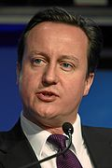
For electoral purposes Britain is divided into constituencies; citizens in all the various British constituencies vote for their local MP. The British government is elected for 5 years and it is the Prime Minister who chooses the date of the next General Elections. When the date is announced the Prime Minister usually asks the Queen to dissolve Parliament. So, the election campaign is launched all over the country and it usually lasts about three weeks. Voting takes place on Polling Day. When the results are known and it becomes clear what party has a majority of seats in the House of Commons, its leader forms a government by Her Majesty's request.
David William Donald Cameron is the Prime Minister of the United Kingdom and Leader of the Conservative Party. Cameron has a public image of a young, moderate candidate who can appeal to young voters. At age 43, Cameron became the youngest British Prime Minister since Lord Liverpool, who was appointed in 1812. The Cameron Ministry is the first coalition government in the United Kingdom since the Second World War. The Conservatives and Liberal Democrats control 363 seats in the House of Commons, with a majority of 76 seats.
Cameron describes himself as a "modern compassionate conservative" and has spoken of a need for a new style of politics. He has stated that he is a big Thatcher fan. He has also claimed to be a "liberal Conservative", and "not a deeply ideological person. In the first month of Cameron's leadership, the Conservative Party's standing in opinion polls rose.
Make the annotation of the text in Russian.

КОНТРОЛЬНАЯ РАБОТА №2
ВАРИАНТ I
Задание I. Прочитайте и переведите весь текст устно. Перепишите 7,8, 9 абзацы текста и переведите их письменно. К собеседованию подготовьте чтение и перевод всего текста.
The British Monarchy
The Monarch is really a figurehead representing the country. For thousands of years England (and later whole of the United Kingdom) has been united under one sovereign. The hereditary principle still operates and the Crown is passed to the sovereign’s eldest son or daughter if there are no sons.
Upon the death of the Sovereign, his or her heir immediately and automatically succeeds (hence the phrase "The King is dead. Long live the King!"), and the accession of the sovereign is publicly proclaimed by an Accession Council that meets at St. James's Palace. The monarch is crowned in Westminster Abbey, normally by the Archbishop of Canterbury. A coronation is not necessary for a sovereign to reign; indeed, the ceremony usually takes place many months after accession to allow sufficient time for its preparation and for a period of mourning.
On the one hand the Queen is one of the richest women in the world. The Crown Estate is one of the largest property owners in the United Kingdom, with holdings of £7.3 billion in 2011. But on the other hand her power is limited by the fact that many of her expenses are paid for by government money. The Civil List covers most expenses, including those for staffing, state visits, public engagements, and official entertainment. Its size is fixed by Parliament every 10 years; any money saved may be carried forward to the next 10-year period.
In accordance with unwritten constitutional conventions, the Sovereign must appoint an individual who commands the support of the House of Commons, usually the leader of the party or coalition that has a majority in that House. The Prime Minister takes office by attending the Monarch in private audience, and after Kissing Hands that appointment is immediately effective without any other formality or instrument.
In a "hung parliament", in which no party or coalition holds a majority, the monarch has an increased degree of latitude in choosing the individual likely to command most support, but it would usually be the leader of the largest party. Since 1945, there have only been two hung parliaments.
The monarch could in theory unilaterally dismiss a Prime Minister, but a Prime Minister's term now comes to an end only by electoral defeat, death, or resignation. But the Queen has the power to prevent any politician from establishing a dictatorship.
Some of the government's executive authority is theoretically and nominally vested in the Sovereign and is known as the Royal Prerogative. The monarch acts within the constraints of convention and precedent, only exercising prerogative on the advice of ministers responsible to Parliament, often through the Prime Minister or Privy Council. In practice, prerogative powers are only exercised on the Prime Minister's advice—the Prime Minister, and not the Sovereign, has control. The monarch holds a weekly audience with the Prime Minister. The monarch may express his or her views, but, as a constitutional ruler, must ultimately accept the decisions of the Prime Minister and the Cabinet
The Royal Prerogative includes the powers to appoint and dismiss ministers, regulate the civil service, issue passports, declare war, make peace, direct the actions of the military, and negotiate and ratify treaties, alliances, and international agreements.
It is the prerogative of the monarch to summon and prorogue Parliament. Each parliamentary session begins with the monarch's summons. The new parliamentary session is marked by the State Opening of Parliament, during which the Sovereign reads the Speech from the Throne in the Chamber of the House of Lords, outlining the Government's legislative agenda.
The Monarch takes little direct part in Government. The decisions to exercise sovereign powers are delegated from the Monarch, either by statute or by convention, to Ministers or officers of the Crown, or other public bodies, exclusive of the Monarch personally. Thus the acts of state done in the name of the Crown, such as Crown Appointments,] even if personally performed by the Monarch, such as the Queen's Speech and the State Opening of Parliament, depend upon decisions made by others.
The Sovereign's role as a constitutional monarch is largely limited to non-partisan functions, such as granting honours.
Задание II. Выпишите все незнакомые слова. Найдите в тексте следующие слова и словосочетания, найдите их транскрипцию в словаре, выучите их. Знание слов будет проверяться на собеседовании.
созывать
отправлять в отставку министров
свобода
прием гостей
номинальный глава
исключительное право
наследный принцип
после вступления
проигрыш
имущество короны
вести переговоры
уход в отставку
расходы
Задание III. Найдите в 1,2,10 абзаце текста предложения, в которых употребляется Participle I, Participle II, выпишите и переведите их на русский язык.
Задание IV. Найдите в 4,5,6 абзаце текста предложения, в которых употребляется Gerund, выпишите и переведите их на русский язык.
Задание V. Найдите в 8,9 абзаце текста предложения, в которых употребляется Infinitive, выпишите и переведите их на русский язык.
Задание VI. Переведите предложения на русский язык, обращая внимание на значение модальных глаголов и их эквивалентов.
1. The Monarchy existed some four hundred years before Parliament and tree centuries before the first courts of law, and an almost unbroken line of kings and queens can be traced back for over a thousand years.
2. The Queen is expected to be impartial or “above politics”, and any advice she may offer the Prime Minister is kept secret.
3. The Queen might refuse a prime ministerial request to appoint peers to the House of Lords where the reason for the request is to flood the Lords with government supporters.
4. The Queen might refuse royal assent where the refusal is on the advice of the prime minister.
5. The Queen must still give assent because the will of Parliament has a higher constitutional status than that of the executive.
6. The Queen is able to refuse a dissolution if the prime minister is acting clearly unconstitutionally.
7. In a few special cases it is believed that the monarch has to exercise personal power.
8. The monarch may express his or her views, but, as a constitutional ruler, must ultimately accept the decisions of the Prime Minister and the Cabinet.
9. The monarch doesn’t have to take an active part in the political life of the UK.
10. The monarch could in theory unilaterally dismiss a Prime Minister.
Задание VII. Переведите предложения на русский язык, обращая внимание на сослагательное наклонение.
1. If only one monarch has used a particular name, no ordinal is used; for example, Queen Victoria is not known as "Victoria I", and ordinals are not used for English monarchs who reigned before the Norman conquest of England.
2. If a government is defeated on a vote of confidence in the House of Commons but refuses to resign or to advise a dissolution the Queen could probably dismiss the government.
3. If Her Majesties Government is defeated on a vote of confidence in the House of Commons, Her Majesties Opposition could form a majority, could be placed in office or the Queen could dissolve Parliament, thus putting the case to the people through an election.
4. The Queen could dismiss a government if it violates a basic constitutional principle, for example by proposing legislation to abolish elections.
5. If there was an election tomorrow, who would you vote for?
6. If I found a wallet in the street, I’d take it to the police station.
7. I’d be very frightened if somebody pointed a gun at me.
8. The Queen could dissolve Parliament, if Her Majesties Government lost her confidence.
Задание VIII. Задайте вопросы к выделенным словам.
1. Prerogative powers are only exercised on the Prime Minister's advice—the Prime Minister, and not the Sovereign, has control.
2. The Queen has the power to prevent any politician from establishing a dictatorship.

КОНТРОЛЬНАЯ РАБОТА №2
ВАРИАНТ II
Задание I. Прочитайте и переведите весь текст устно. Перепишите 1,2,3 абзацы текста и переведите их письменно. К собеседованию подготовьте чтение и перевод всего текста.
The United Kingdom is a political union made up of four constituent countries: England, Scotland, Wales, Nothern Ireland and several overseas territories, including Gibraltar and the Falkland Islands. The UK is a highly developed country, a member of the Group of Eight (GE), member of the European Union (EU), is a founding member of the North Atlantic Treaty Organisation (NATO), the United Nations (UN), where it holds a permanent seat in the Security Council.
Britain is a parliamentary democracy what can be seen through free elections, freedom of speech and open and equal treatment before the law. The British monarchy in this country has been for many centuries and it is known for being a constitutional monarchy (or parliamentary monarchy). The head of the state is the Queen but the power of Her Majesty the Queen of the UK is limited by the British Parliament. That is why they often say that the monarch in this country reigns but does not rule. Although the British Sovereign no longer has a political or executive role, he or she continues to play an important part in the life of the nation.
In reality, the House of Commons is the only one of the three having true power. It is here that new bills are introduced and debated. If the majority of the members are in favor of a bill it goes to the House of Lords to be debated and finally to the monarch to be signed. Only then it becomes law. The House of Lords is known to be the upper house of the Parliament, but it seems the less powerful part of Parliament. It consists of non-elected members : hereditary peers, life peers and about 30 Law Lords.
The British parliamentary system depends on political parties. Since 1945 the British Government is constantly represented by two political parties: Conservative (who are called "Tory" by their opponents) and Labour (called "Whigs"). In 1988 the Liberal Party made an alliance with Social Democrats and the Party of Liberal Democrats was formed.
The Conservative Party, often called Tory Party, is that of big business, industry, commerce and landowners. It is the most powerful party and is often called a party of business directors. The Labour Party, formed in 1900, was the one which drew away working people’s support. There are also some other parties: the Scottish National and Welsh Nationalist parties, the Communist party of Britain and the Communist party of Great Britain.
The Prime Minister of the United Kingdom of Great Britain and Northern Ireland is the Head of Her Majesty's Government in the United Kingdom. The operating Prime Minister, David Cameron, leader of the Conservative Party, was appointed on 11 May 2010.
As the "Head of Her Majesty's Government" the modern Prime Minister leads the Cabinet (the Executive). In addition the Prime Minister leads a major political party and generally commands a majority in the House of Commons. He is responsible for appointing and dismissing ministers. In the House of Commons, the Prime Minister guides the law-making process with the goal of enacting the legislative agenda of their political party.
The British system of government is based on an "unwritten" constitution, meaning that it is not codified into a single document. Scattered across 800 years, the British constitution consists of many documents—such as Magna Carta (1215), the Great Reform Bill (1832), and the Parliament Act (1911)—and, most important for the evolution of the office of Prime Minister, customs known as conventions that became accepted practice.
Задание II. Выпишите все незнакомые слова. Найдите в тексте следующие слова и словосочетания, найдите их транскрипцию в словаре, выучите их. Знание слов будет проверяться на собеседовании.
совет по безопасности
полное рассмотрение
наследные пэры
землевладельцы
привлекать, получать
Правительство Ее Величества
руководить большинством
отправлять министров в отставку
законодательный процесс
законодательная инициатива
должность Премьер министра
общепринятая практика
Задание III. Найдите в 5,6,8 абзаце текста предложения, в которых употребляется Participle I, Participle II, выпишите и переведите их на русский язык.
Задание IV. Найдите в 2,7 абзаце текста предложения, в которых употребляется Gerund, выпишите и переведите их на русский язык.
Задание V. Найдите в 3 абзаце текста предложения, в которых употребляется Infinitive, выпишите и переведите их на русский язык.
Задание VI. Переведите предложения на русский язык, обращая внимание на значение модальных глаголов и их эквивалентов.
1. The Queen can reign but can’t rule.
2. The House of Commons can introduce a new legislation.
3. The Prime Minister must lead the majority party, run the Government, appoint Ministers, represent the nation in political matters.
4. Britain is a parliamentary democracy what can be seen through free elections, freedom of speech and open and equal treatment before the law.
5. Upon accepting the office the Prime Minister must form a government.
6. Each party is able to conduct its own election campaign with meetings, speeches and television commercials.
7. The Queen might refuse royal assent where the refusal is on the advice of the prime minister.
8. The monarch may express his or her views, but, as a constitutional ruler, must ultimately accept the decisions of the Prime Minister and the Cabinet.
9. The British constitution can be called "unwritten" because it is not codified into a single document.
10. I have to work from 8.30 till 5.30 every day.
Задание VII. Переведите предложения на русский язык, обращая внимание на сослагательное наклонение.
1. The Prime Minister could dismiss the ministers of his Cabinet if they violate a basic constitutional principle, for example by proposing legislation to abolish elections.
2. If the Prime Minister is defeated on a vote of confidence in the House of Commons but refuses to resign or to advise a dissolution, the Queen could probably dismiss the Prime Minister and his government.
3. If Her Majesties Government is defeated on a vote of confidence in the House of Commons, Her Majesties Opposition could form a majority, could be placed in office or the Queen could dissolve Parliament, thus putting the case to the people through an election.
4. If I don’t have a car, I won’t spend so much money on petrol.
5. If I could speak six languages, I’d become an interpreter at the United Nation.
6. If my country was bigger, we would become a more important military power in Europe.
7. If I studied law, I would have to spend a lot of time learning by heart.
8. If the car breaks down, we won’t catch the train.
9. The United Kingdom was an absolute monarchy, the Queen would be the supreme authority.
Задание VIII. Задайте вопросы к выделенным словам.
1. The House of Lords consists of non-elected members : hereditary peers, life peers and about 30 Law Lords.
2. The Prime Minister leads a major political party and generally commands a majority in the House of Commons.

